ESP2107 Assignment on Numerical Methods and Statistics: Modelling the Spread of COVID-19

A0199806L

1. Essay on autodidacticism

Socrates once said, “Education is the kindling of a flame, not the filling of a vessel.” Learning is a lifelong process and as such, we should not depend on education for our learning. As societal progression accelerates, can modern education continue to keep up with its pace? Education has its own limitations and hence, as lifelong students, we have to turn to other tools to “fill the vessel”.

Autodidacticism is self-directed learning without the guidance of masters or institutions. It is a skill instrumental to our lifelong learning; more important than a calculator is to a mathematician or a microscope is to a scientist. A research study conducted in Hacettepe University and Başkent University, titled “An Investigation of Self-Directed Learning Skills of Undergraduate Students” showed that self-directed learning skills have a positive impact on lifelong learning tendencies. Due to rapid technological advances, numerous discoveries are made and our understanding of the world expands, it is inevitable that our modern education system no longer suffices and hence, the need for it to adapt to these developments. In addition, due to finite resources, it might not be practical to provide education for every single individual in the world. According toEducation, Audiovisual and Culture Executive Agency (EACEA), the number of university students in Europe are increasing rapidly, causing an increased student-to-lecturer ratio.

The advent of the COVID-19 pandemic perfectly demonstrated the importance of autodidacticism as education institutes and teachers have limited communication with their students. Self-discipline and self-accountability, being the essences of autodidacticism, everyone is responsible for their own learning in the light of limited monitoring and guidance from their respective institutes and teachers. Considering modern technological marvels, the pandemic and thus the lack of interactions between students and teachers should be of no excuse for students not to continue their learning. With a few swipes and taps on the smartphone, one can easily have access to a vast ocean of information - the internet. Therefore, the pandemic should not be an obstacle for our learning.

However, as much as autodidacticism is important, it can also be dangerous. As the internet is easily accessible to anyone, one must be careful of the information encountered online. Therefore, it is of paramount importance that institutes and teachers equip their students with the tools to correctly and efficiently source for information; to discern the accurate facts from false information. As such, despite the necessity for students to take responsibility and control of their own learning, there is still a need for institutes, teachers and students to work hand-in-hand to bolster students’ autodidacticism and to guide them in the right direction.

2.1 Purpose of report

To study the spread of COVID19, a model would be beneficial in understanding the outbreak of the virus. Thus, this report looks at the modelling of its spread by solving ordinary differential equations (ODEs) with the aid of Matlab.

2.2 Modelling of COVID19

Kermack-McKendrick epidemic model, also known as the susceptible-infectious-recovered (SIR) compartment model, is a popular model used to describe the spread of infectious disease. The model categorise each of the individuals in a given population into the following 3 groups:

1. S(t) - Susceptible: Individuals who currently does not have the virus, but are susceptible to it and can become infectious when having an infectious contact with an infected individual
2. I(t) - Infectious: Individuals who currently have the virus and are able to infect others with the virus
3. R(t) - Recovered: Infectious individuals who currently do not have the virus and are unable to transmit the virus anymore. (This model assumes that no re-infection can occur, i.e. recovered individuals are immune to the virus once they contracted it). Deaths are classified into this category as these individuals can no longer infect others and are considered as “recovered”.

2.3 Obtaining Ordinary Differential Equations (ODEs)

These 3 groups are mathematical functions with respect to time, t. For this model, the total population, N $=1×{10}^{6}$, is assumed to be constant. Hence, S(t) + I(t) + R(t) = N where there are no births and all deaths are due to the virus. Next two variables are introduced:

1. β: Represents the rate of infectious contacts. Assuming everyone contacts a specific person at a rate of α, and a proportion of these individuals, p, are infectious; in mathematical form, β=αp.
2. $γ$: Represents the recovery rate of infectious individuals. Assuming that on average, a person is k number of days infectious before they recover; in mathematical form, $γ=1/k$.

Using these variables, the following 3 ordinary differential equations (ODEs) are derived:



$\frac{dS(t)}{dt}= -βS(t)I(t)$

$\frac{dI(t)}{dt}= βS(t)I(t)-γI(t)$

$\frac{dR(t)}{dt}= γI(t)$

2.4 Initial conditions

From this system, an instrumental quantity - basic reproduction number, $R_{0}=N\frac{β}{γ}$, can be derived. Assuming R(0) = 0 and letting I(0)=m, S(0) = N - m, and the initial conditions are obtained.

3.1 Solving of model

For this model, total population is assumed to be $1×{10}^{6}$, m is 10, β is $4.5×{10}^{-7}$, $γ$ is 0.2 which corresponds to the average length of the infective period(k) of 5 days. These parameters leads to a $R_{0}$ value of 2.25 which is approximately the corresponding $R_{0}$ value of SARS-CoV-2. Using both Euler’s method and MATLAB’s built-in method(ode45) to solve for the ODEs, the results are then compared. The MATLAB codes for the algorithm are attached in the appendix.

3.2 Results

­­­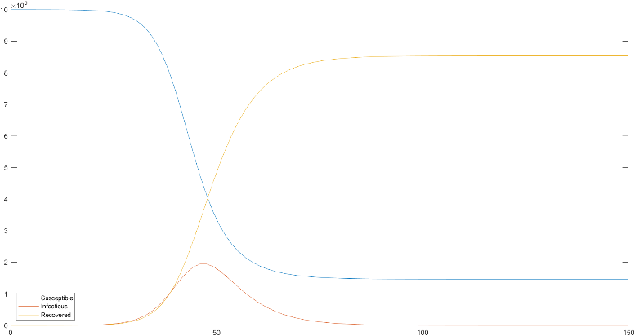

Figure 1. Results using Built-in method(ode45)

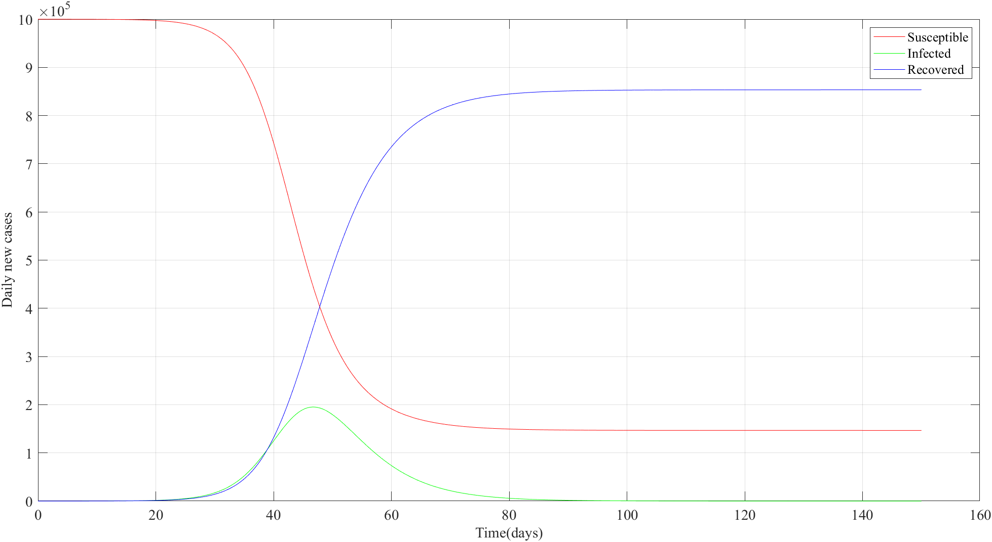

Figure 2. Results using Euler’s method

The results are similar for both MATLAB’s built-in method and Euler’s method. ­­Both the model shows the pandemic peak after approximately 50 days at $2×{10}^{5}$ daily new cases and which gradually decreases to 0 after approximately 80 to 100 days.

3.3 Evaluation of model

This model is more realistic than the models created in the early days of the pandemic where the number of cases is predicted to be exponentially increasing and are over-exaggerated. With this model, measures can aim to control the values of the parameters in the SIR model to effectively curb the pandemic. However, for the Euler’s method to be stable, the step size, h which is equals to (b-a)/N must be sufficiently small. In addition, there are many assumptions made in this model.

For example, it is assumed that once an infected individual comes into contact with a susceptible individual, the susceptible individual will be infected which might not be the case in real life. However, as this is an over-estimation, the implication is not as severe.

It is also assumed that a person gains immunity once infected with the virus. In reality, there have been reports of reinfection occurring. However, these cases are rare.

Lastly, it is also assumed that the total population remains constant. Hence, the model can be improved by considering birth and death rate due to other factors excluding the virus itself.

4. Conclusion

The SIR model is effective for governments and organisations to design measures for a pandemic. However, other parameters and model such as the Susceptible, Exposed, Infectious, Recovered, Susceptible (SEIR) model can be considered to improve the accuracy of the model.

Moreover, Euler’s method might not be appropriate in all situations and hence, other methods can be considered. One such method is the Heun’s method which is built upon the Euler’s method. It is a second-order convergent compared to Euler’s method which is a first-order convergent. Hence Heun’s method is relatively more accurate and does not require as small of a step size as that of Euler’s method.

5. References

1.https://advancesindifferenceequations.springeropen.com/articles/10.1186/1687-1847-2014-278

2.https://staff.math.su.se/hoehle/blog/2020/03/16/flatteningthecurve.html

3.http://calculuslab.deltacollege.edu/ODE/7-C-2/7-C-2-h.html

6. Appendix

Code for built-in method

time_range=[0,150];

s0=1000000;

i0=10;

r0=0;

initial_w=[s0;i0;r0];

[t_values,sol_values] = ode45(@(t,w) diff_eq(t,w),time_range,initial_w);

plot(t_values,sol_values);

legend({'Susceptible','Infectious','Recovered'},'Location','southwest')

function dw_vectordt = diff_eq(t,w_vector)

s = w_vector(1);

i = w_vector(2);

r = w_vector(3);

b = 4.5e-07;

gamma = 1/5;

dsdt = -b*s*i;

didt = b*s*i - gamma*i;

drdt = gamma*i;

dw_vectordt = [dsdt; didt;drdt];

end

Code for Euler’s method

%%

% EULER'S METHOD FOR INITIAL-VALUED ODEs

%

%

%

%%

clc

format long

format compact

%% Parameters

a = 0;

b = 150;

%alpha = R0 for the given program

alpha = 2.25;

% Population size

N = 1000000;

h = (b-a)/N;

m = 10;

%Rate at which person stays in the infectious compartment (disease specific and tracing specific)

gamma = 1/5;

%Infectious contact rate - beta = R0/N*gamma and when R0 \approx 2.25 then 2.25/N*gamma

beta = 4.5e-07;

%% Preallocation

% see https://www.mathworks.com/help/matlab/matlab_prog/preallocating-arrays.html

t=zeros(N,1);

s=zeros(N,1);

in=zeros(N,1);

r=zeros(N,1);

%% Algorithm (Euler method)

t(1) = a;

%Initially, N - m people are susceptible

s(1) = N - m;

%Initially, 0 infected

in(1) = m;

r(1) = alpha;

fprintf('%4d %12.8g %12.8g %12.8g %12.8g\n',0,t(1), s(1), in(1), r(1));

for i=1:N

s(i+1) = s(i) + h * (- beta * s(i) * in(i));

in(i+1) = in(i) + h * (beta * s(i) * in(i) - gamma * in(i));

r(i+1) = r(i) + h * (gamma * in(i));

t(i+1) = t(i) + h;

fprintf('%4d %12.8g %12.8g %12.8g %12.8g\n', i, t(i+1), s(i+1), in(i+1), r(i+1)); %remove for large N

end

%% Postprocessing

% You do not have to learn how to typeset in MATLAB like I do below for the

% labels--only if you are interested.

figure(1)

plot(t,s,'r-')

hold on

plot(t,in,'g-')

plot(t,r,'b-')

hold off

grid on

v=get(1,'currentaxes');

set(v,'fontsize',14,'fontname','Times New Roman')

legend('Susceptible', 'Infected', 'Recovered')

xlabel('Time(days)','fontsize',14,'fontname','Times New Roman')

ylabel('Daily new cases','fontsize',14,'fontname','Times New Roman')